90

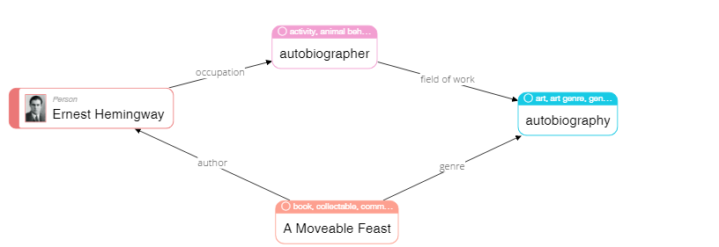

|  |
| --- |
| **Please describe shortly what you see on this diagram? Pay attention only to that information that is understandable or has sense for you.** |
| Ernest Hemingway wrote an autobiography piece that is called “A moveable feast” |

68

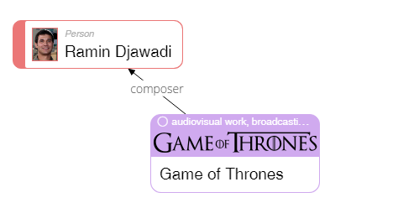

|  |
| --- |
| **Please describe shortly what you see on this diagram? Pay attention only to that information that is understandable or has sense for you.** |
| Ramin Djawadi composed soundtrack for the Game of Thrones TV series. |

23

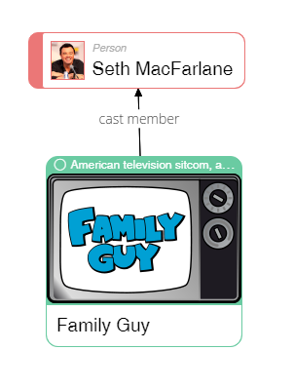

|  |
| --- |
| **Please describe shortly what you see on this diagram? Pay attention only to that information that is understandable or has sense for you.** |
| Seth MacFarlane played a part in Family Guy TV sitcom. |

50

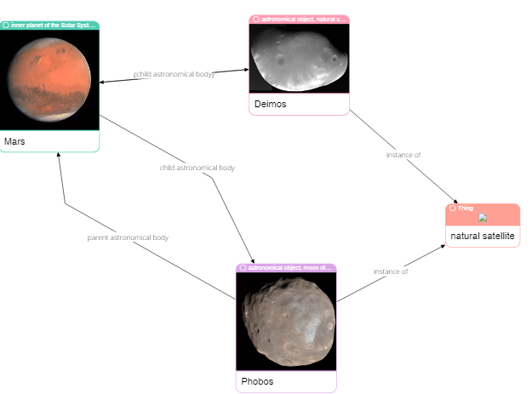

|  |
| --- |
| **Please describe shortly what you see on this diagram? Pay attention only to that information that is understandable or has sense for you.** |
| Demos and Phobos are two natural satellites of Mars |

62

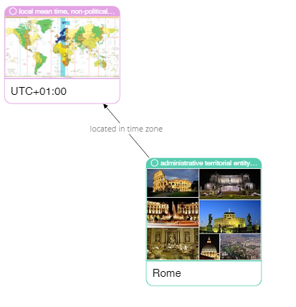

|  |
| --- |
| **Please describe shortly what you see on this diagram? Pay attention only to that information that is understandable or has sense for you.** |
| Rome is located in UTC+1 time zone, which one hour ahead of London. |

75

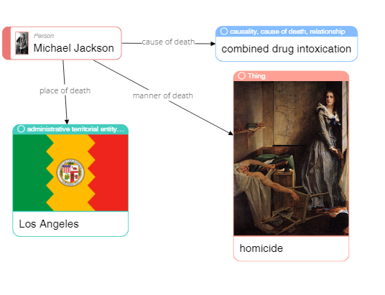

|  |
| --- |
| **Please describe shortly what you see on this diagram? Pay attention only to that information that is understandable or has sense for you.** |
| Michael Jackson died from drug abuse in Los Angeles. |

79

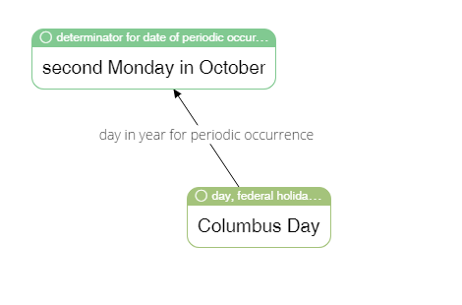

|  |
| --- |
| **Please describe shortly what you see on this diagram? Pay attention only to that information that is understandable or has sense for you.** |
| Columbus day is celebrated on the second Monday of October. |

65



|  |
| --- |
| **Please describe shortly what you see on this diagram? Pay attention only to that information that is understandable or has sense for you.** |
| Ole Kirk Christiansen invented and commercialized LEGO while working as carpenter and joiner. |

4

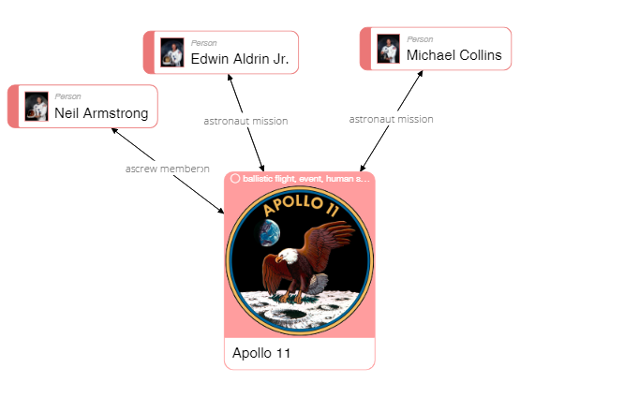

|  |
| --- |
| **Please describe shortly what you see on this diagram? Pay attention only to that information that is understandable or has sense for you.** |
| Apollo 11 crew consisted of Neil Armstrong, Edwin Aldrin Jr. and Michael Collins. |

40

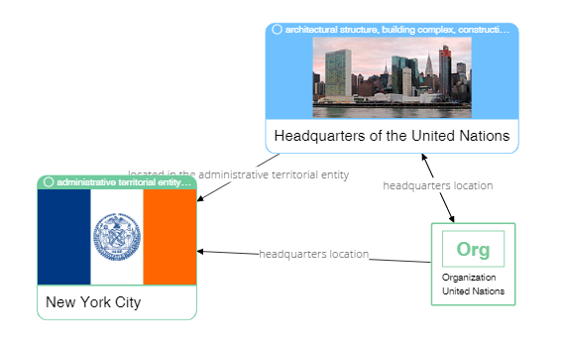

|  |
| --- |
| **Please describe shortly what you see on this diagram? Pay attention only to that information that is understandable or has sense for you.** |
| The headquarters of United Natation organization are located in New York. |

37



|  |
| --- |
| **Please describe shortly what you see on this diagram? Pay attention only to that information that is understandable or has sense for you.** |
| The main training facility for Porto Football club is Estadio do Dragao. |